**C:\Documents and Settings\slong1\Local Settings\Temporary Internet Files\Content.Outlook\OY3UFDG0\Logos AD LO E_BW.jpg**

**Diners Club/BMO Corporate T&E MasterCard   
Secure e-Account Manager Online Account Set Up**

Take control of your Diners Club® corporate account with e-Account Manager that will allow access to your account in a secure and easy-to-use online environment. When you register with e-Account Manager, you can:

* Manage your account online 24/7, where you will have the ability to:
  + Pay your bill
  + View current and past statements from the past 12 months
  + Dispute charges
  + Sign up for e-mail alerts, and more
  + Access your Membership Sourcebook, which highlights all of the features and benefits available to you as a Diners Club Card member.

**https://www.dinersclubus.com/homeHere’s how to register:**  
Visit [**dinersclubus.com**](http://www.dinersclubus.com/)and click “Register” under Secure e-AccountManagement on the left-hand side of the page:

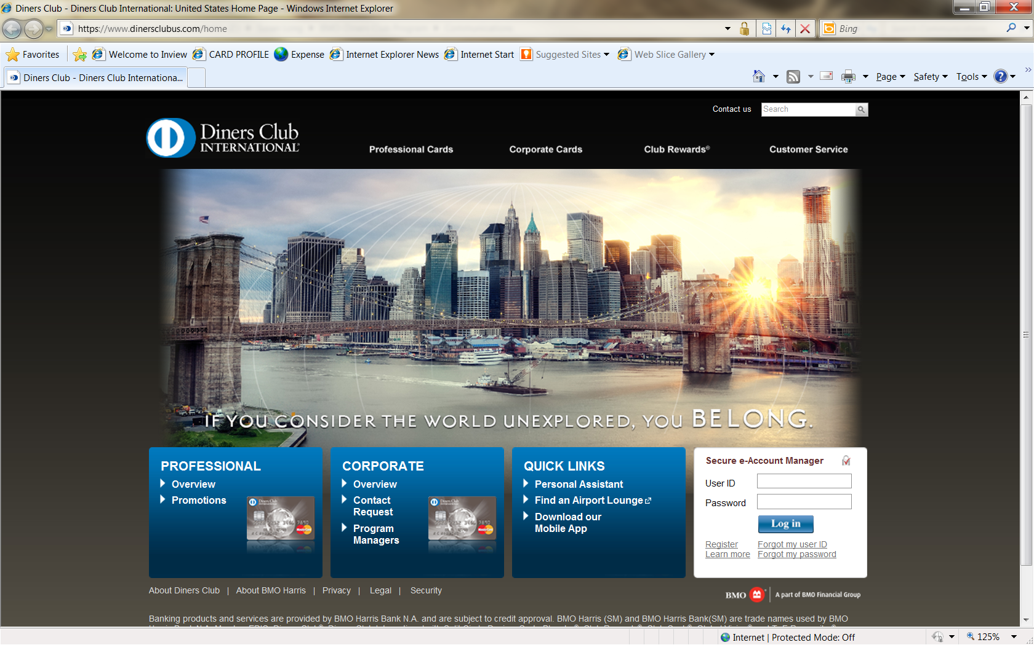

From the Home page you will be able to navigate to several areas for Account Services:

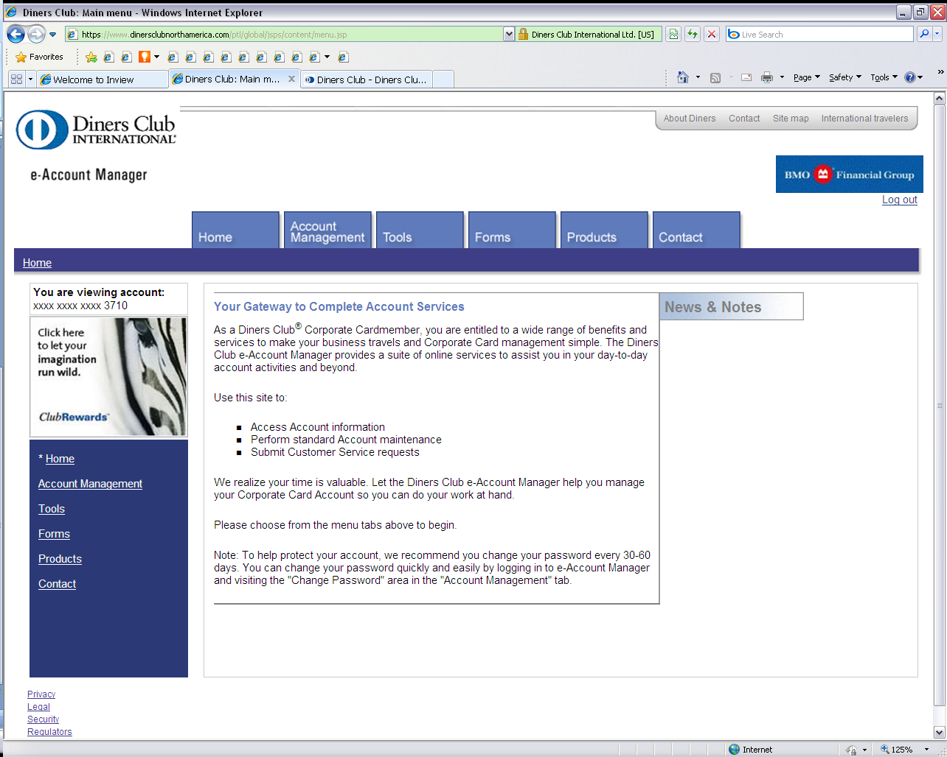

***Account Management***   
Keeping your account up-to-date is important, and Diners Club/BMO MasterCard have provided tools for you to do just that – view statements, pay your bill on-line, change your address or phone number, set up Diners Club On The Go Alerts, and change User ID or Password. NOTE: On-line bill pay can be set upon making your first payment and if selected the information will be stored for future payments.   
 ***Tools***Easy-to-use tools and links that will help you make the most of the Diners Club program. Access to Diners Club International Airport Lounge Locator, Club Rewards (optional if you choose to enroll) or Diners Club Global Network.

***Forms***Quick and easy access to enrolling in some of Diners Club's programs and services.

***Products***Lists advantages that come along with carrying a Diners Club/BMO MasterCard

***Contacts***e-Account Manager FAQ’s and Customer Service Information

Questions about registering your account with e-Account Manager, please call   
***1 800 2 DINERS*** ***(1-800-234-6377)***